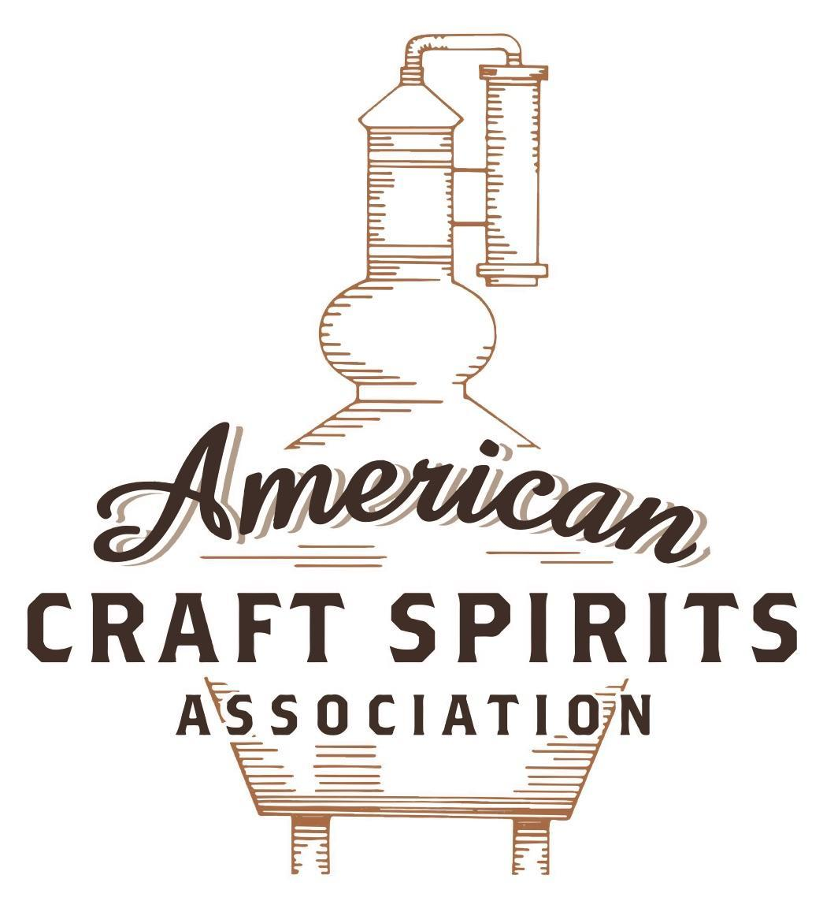
Spirits DtC Shipping Guide

This guide summarizes the direct-to-consumer shipping rules for distilleries in all 50 states and D.C. and also addresses the measures state governments have taken to ease delivery and shipping restrictions during the COVID-19 pandemic.

DtC Quick Guide Comparison

Out-of-State Distilleries  Can Ship Into State? |  |  |  | In-State Distilleries  Can Ship Within State?
State | Yes | No |  | State | Yes | No
AL |  | X |  | AL |  | X
AK | X |  |  | AK | X
AZ | X |  |  | AZ | X
AR |  | X |  | AR |  | X
CA |  | X* |  | CA |  | X*
CO |  | X |  | CO |  | X
CT |  | X* |  | CT |  | X
DE |  | X |  | DE |  | X
DC | X |  |  | DC | X
FL |  | X |  | FL |  | X
GA |  | X |  | GA |  | X
HI |  | X* |  | HI |  | ?*
ID |  | X |  | ID |  | X
IL |  | X* |  | IL |  | X*
IN |  | X |  | IN |  | X
IA |  | X* |  | IA |  | X*
KS |  | X |  | KS |  | X
KY | X |  |  | KY | X
LA |  | X |  | LA |  | X
ME |  | X* |  | ME |  | X*
MD |  | X |  | MD |  | X
MA |  | X |  | MA |  | X
MI |  | X |  | MI |  | X
MN |  | X |  | MN |  | X
MS |  | X |  | MS |  | X
MO |  | X |  | MO |  | X
MT |  | X |  | MT |  | X
NE | X |  |  | NE | X
NV |  | X* |  | NV |  | X
NH | X |  |  | NH |  | X*
NJ |  | X* |  | NJ |  | X*
NM |  | X |  | NM |  | X
NY |  | X* |  | NY |  | X*
NC |  | X |  | NC |  | X
ND | X |  |  | ND | X
OH |  | X |  | OH |  | X
OK |  | X |  | OK |  | X
OR |  | X |  | OR | X
PA |  | X* |  | PA |  | X
RI |  | X* |  | RI |  | X
SC |  | X |  | SC |  | X
SD |  | X |  | SD |  | X
TN |  | X |  | TN |  | X
TX |  | X |  | TX |  | X
UT |  | X |  | UT |  | X
VT |  | X |  | VT |  | X
VA |  | X |  | VA |  | X
WA |  | X* |  | WA | X
WV |  | X* |  | WV |  | X*

WI |  | X |  | WI |  | X
WY |  | X |  | WY |  | X

Notes:
*CA: If passed and signed into law, Senate Bill 620 would allow licensed distilled spirits producers in states other than California and licensed distilled spirits manufacturers or craft distillers in California who obtain distilled spirits direct shipper permits to ship directly to consumers in California
*CT: Consumers with appropriate permit may receive alcohol shipments
*HI: Consumers with appropriate permit may receive alcohol shipments; If passed and signed into law, Senate Bill 65 would allow licensed distilled spirits manufacturers in Hawaii and in states other than Hawaii who obtain direct shipper permits to ship directly to consumers in Hawaii
*IL: If passed and signed into law, Senate Bill 0532 would allow licensed distilled spirits producers in Illinois and in states other than Illinois who obtain distillery shippers’ licenses to ship directly to consumers in Illinois
*IA: If passed and signed into law, House File 639 would allow native distilled spirits manufacturers in Iowa and in states other than Iowa who obtain direct shipper permits to ship directly to consumers in Iowa and to consumers in states other than Iowa
*ME: If passed and signed into law, Legislative Document 1358 would allow distilleries outside of Maine with current manufacturer licenses and distilleries licensed in Maine who obtain spirits direct shipper licenses to ship directly to consumers in Maine
*NJ: (1) If passed and signed into law, Assembly Bill 3167 would allow a craft distillery licensees to ship no more than 9 liters of distilled spirits to a consumer in New Jersey; (2) If passed and signed into law, Senate Bill 3020 would allow craft distillery licensees in New Jersey or in states other than New Jersey to ship no more than 20 liters of distilled spirits to a consumer in New Jersey via common carrier
*NV: Licensed individuals can import one gallon per month of spirits for personal use and the out-of-state supplier must pay excise tax
*NH: If passed and signed into law, Senate Bill 125 would allow licensed liquor manufacturers who obtain direct to consumer shipping permits from the commission to ship directly to consumers in New Hampshire
*NY: Consumer may import up to 90L of liquor per year for personal use without a license; If passed and signed into law, Assembly Bill 3275 would allow licensed liquor manufacturers in states other than New York and licensed distillers and farm distillers in New York to ship no more than thirty-six cases (no more than nine liters per case) of liquor to consumers in New York
*PA: Consumer may place a special liquor order and distiller must ship to a PLCB-operated store
*RI: Distiller can only ship to customer if order was personally placed by customer at distiller's premises
*WA: If passed and signed into law, House Bill 1432 would allow licensed spirits manufacturers in states other than Washington to ship spirits to consumers in Washington
*WV: Distilleries, mini-distilleries, or micro-distilleries licensed in West Virginia or a state other than West Virginia who obtain private direct shipper licenses to ship to a consumer in West Virginia, however the shipments must be made to a retail liquor outlet

ALASKA
Shipment outbound – No, a person must be present on the licensed premises to purchase spirits (AS Section 04.11.170(b)(1)).
Shipment inbound – Yes, as long as spirit is not shipped to a dry community. List of alcohol restrictions by community: https://www.commerce.alaska.gov/web/Portals/9/pub/ABC/DryDampCommunities/LocalOption10152020.pdf
Shipment intrastate – Yes, via a written order and in accordance with the requirements set out in 3 AAC 304.645 and any local community rules where product is to be shipped.
COVID-19 Measures – The ABC Board waived fees to submit AB-29: Waiver of Operation Application. According to AS Sec. 4.11.330(d), an application renewal can be denied if the applicant did not operate the licensed premises for at least 240 hours during each of the preceding two calendar years (unless the board determines that the premises could not be operated because of construction through no fault of the application). The order was entered into July 16, 2020 and was effective for the remainder of 2020.
Link: https://www.commerce.alaska.gov/web/Portals/9/pub/homePage/AdvisoryWaiver.pdf
Citation (shipment)
Alaska ABC Board FAQs
Does Alaska regulate importation for personal use?
Alaska does not limit or tax alcoholic beverages brought into this state for personal use and not for resale. Out-of-state suppliers may ship alcoholic beverages to Alaska residents. Over 75 Alaska communities have, by local option, banned the importation or possession of alcoholic beverages. It may be a felony crime to ship alcoholic beverages to those communities. A list of those communities can be found on the Alcohol Local Option page of this web site.
Can I have alcohol sent to me from out of state?
Yes, as long as it is for personal use, not for resale, you do not live in a local option (dry) community, and it is not sent through the United States Postal Service (USPS).
Link:
https://www.commerce.alaska.gov/web/amco/AlcoholicBeverageFAQs.aspx?TSPD_101_R0=0890181cafab2000ac0c31d48 06ce2bb660e4e86abf102a7e23effb30cc34d40f01e357ba24c8ec808e0c44c64143000a527ed1731e7d3c72677f5ce857df8cf7 31c1d4e12d53c0dd230e6f67f35cb5eaec9abdbd816cbadd27e9304292bbeb8

Alaska Statutes
AS Sec. 04.11.170. Distillery license.
(b) A distillery license authorizes the holder to sell alcoholic beverages in
(1) quantities of not more than one gallon a day to a person who is present on the licensed premises for consumption off the premises.
AS Sec. 04.16.125. Alcoholic beverages transported by common carrier.
(a) A person may not use a common carrier to transport alcoholic beverages into an area that has restricted the sale of alcoholic beverages under AS 04.11.491(a)(1), (2), or (3) or (b)(1) or (2) unless
(1) the shipping container holding the alcoholic beverages is clearly labeled as containing alcoholic beverages with letters that contrast in color to the shipping container and that are at least two inches in height; and
(2) an itemized invoice showing the quantity and purchase value of distilled spirits, of wine, and of malt beverages is attached to the outside of the shipping container.
(b) This section does not apply to
(1) a person transporting not more than
(A) two liters of wine;
(B) one gallon of malt beverages; or
(C) one liter of distilled spirits; or
(2) the transportation of alcoholic beverages for use on premises allowed under AS 04.11.491(a)(2) — (3) or (b)(2) or for use under a permit allowed under AS 04.11.491(a)(2).

Link to Statutes: https://www.commerce.alaska.gov/web/Portals/9/pub/ABC/AlcoholStatutesRegulations/AS04.pdf

Regulations for the Alaska Alcoholic Beverage Control Board
3 AAC 304.645. Written orders for alcoholic beverages; other transporting of alcoholic beverages; local governing body authority.
(b) Alcoholic beverages may be sold in response to a written order only if the licensee has the original or a clear photocopy of one of the following documents that bears the purchaser's signature and that shows by date of birth or statement of age that the purchaser is at least 21 years of age:
(1) valid government-issued photographic identification from any state;
(2) a foreign passport.
(c) Alcoholic beverages may be sold in response to a written order only if the written
order
(1) is signed and dated by the purchaser;
(2) describes in reasonable detail the type and quantity of alcoholic beverages being ordered;
(3) refers by number to the purchaser's proof-of-age document required by (b) of
this section;
(4) bears a signature reasonably determined by the licensee to match that on the proof-of-age document; (5) states the physical residence address of the purchaser; the address must be sufficient for the licensee to determine whether the residence is within an area that has restricted the sale, importation, or possession of alcoholic beverages under AS 04.11.491; and
(6) is entered into the written order database established under AS 04.06.095, if the alcoholic beverages are to be shipped to an area that has restricted the sale of alcoholic beverages under AS 04.11.491(a)(1), (2), or (3) or (b)(1) or (2); an order that is subject to this paragraph may not be for an amount of alcoholic beverages that, when added to the amount already shipped in a calendar month to the purchaser, exceeds the amount authorized under AS 04.11.150(g) as indicated in the database.
(d) A written order
(1) except as provided in (2) of this subsection, may be modified by the licensee within five working days after receipt of the written order if the modification is in accordance with an oral or written communication from the purchaser; if a modification is made, the licensee shall note on the original order the date of modification and the manner in which the modification was requested by the purchaser; alcoholic beverages shipped in response to a written order must be packaged and shipped within five working days after receipt of the written order by the licensee or the licensee's agent or employee;
(2) that is required, under AS 04.11.150(g) or 3 AAC 304.640, to be entered into the written order database established under AS 04.06.095 may not be modified after it is entered into the database; in calculating whether alcoholic beverages may be shipped to a purchaser under AS 04.11.150(g), the licensee shall use the date that the order is entered into the database; if the amount ordered, when added to the amount already shipped in a calendar month to the purchaser, exceeds the amount authorized under AS 04.11.150(g) as indicated in the database, the licensee may hold the order for up to 72 hours and reenter it into the database for the next month as a new order; however, if the licensee cannot reenter the order as a new order within 72 hours after receipt, the licensee shall return the order to the purchaser unfilled; if they may be shipped to a purchaser under AS 04.11.150(g) and (e) of this section, alcoholic beverages shipped in response to the written order must be packaged and shipped within five working days after receipt of the written order by the licensee or the licensee's agent or employee.
(e) In response to a written order, a licensee
(1) may not package or deliver alcoholic beverages, or enter a written order into the written order database established under AS 04.06.095, until full payment is received at the licensed premises;
(2) may
(A) personally deliver the alcoholic beverages on the licensed premises to the purchaser or to an individual who may legally possess alcoholic beverages and who is specifically authorized in the written order to receive the purchase and deliver it to the purchaser; to verify the identity of the purchaser or the individual specifically authorized in the written order to receive the purchase, the licensee shall require the purchaser or that individual to present an original of one of the forms of identification listed in (b) of this section; or
(B) ship the alcoholic beverages by common or regulated carrier to the purchaser; if the order is to be shipped to a community that has specified a delivery site under AS 04.11.491(f), the order must be shipped to the purchaser at that delivery site address; and
(3) must package an order that is delivered or shipped under this subsection in a shipping container that bears a non-removable label that identifies the licensee, shows the written order number assigned under (m) of this section, and contains the words "alcoholic beverages" in letters at least two inches high and drawn in lines one-quarter inch wide; additionally, one copy of the sales invoice must be enclosed in a non-removable, sealed envelope securely attached to the shipping container; invoices must be legibly hand written or typed, prepared by the licensee or licensee's agent or employee, and show the description, quantity, unit price, extended price, and total value of the alcoholic beverages in the container; if the container is addressed to a delivery site in a municipality that imposes a sales and use tax on alcoholic beverages under AS 04.21.010(c)(4), or controls the quantity that may be imported under AS 04.21.010(a)(1), the invoice may be retained by a municipality.
(f) The community delivery site must be secure from unauthorized access, reasonably located for access by the public, clean and heated, and controlled by the local governing body to assure protection of orders for purchasers. The site must be open for pick-up by purchasers at least once a week, for three hours between 8 a.m. and 8 p.m. Alcoholic beverages may be claimed from the community delivery site only by the purchaser named on the container. The purchaser shall sign for the order on a form stating that the beverages are not for resale. The local governing body may impose reasonable storage and handling fees chargeable to the purchaser, and may label or mark alcoholic beverage containers processed through the community delivery site. Upon approval of a community delivery site, the board will notify package store licensees who have filed the notice required in AS 04.11.150(a) that written orders for shipment into the community may only be shipped to the community delivery site.
(g) Repealed 5/11/96.
(h) Repealed 5/11/96.
(i) Repealed 5/11/96.
(j) Repealed 9/11/98.
(k) Repealed 5/11/96.
(l) The board will, in its discretion, maintain a list of persons who, under AS 04.16.200, are convicted after 10/24/87 of a violation of AS 04.11.010, and will, in its discretion, provide this list to package store licensees. A licensee who receives the list may not sell alcoholic beverages by written order to a person whose name appears on it until the board gives written notice to the licensee that such sales are no longer prohibited.
(m) A licensee shall fasten together the documents pertaining to each written order, and shall keep them on file with the purchaser's proof- of-age document. The licensee shall retain the order documents for at least one year after delivery of the order. In addition, the licensee shall maintain a log of written orders in a manner that allows cross-reference to the documents for each order. The log must assign an order number to each written order, and must show for each order the purchaser's name, dates the order was received, modified, and shipped or delivered, and the address to which shipment was made.
Link to Regulations:
http://www.akleg.gov/basis/aac.asp#3.304.645

The American Craft Spirits Association (ACSA) is working diligently to give our members and industry partners relevant, current updates on statutes and regulations impacting production, sale and distribution of spirits. With the declaration of the novel coronavirus (COVID-19) in early 2020, many states have issued temporary policy changes or longer-term modernization of alcohol beverage laws. State statutes, regulations created by the state alcohol regulatory authority, as well as any other relevant guidance provided by such authorities (such as advisories, opinions, bulletins, etc.) were reviewed in creation of this document. No city or county ordinances were reviewed. Distillers should be aware that even in states where direct shipping is permissible, always remember to avoid shipping to dry counties. Please consult with your state guild or alcohol beverage authority for the most up-to-date information. This content is intended for educational and informational purposes only. ACSA's pro bono law firm of Malkin Law P.A. provided the core content found in this comprehensive overview of the spirits distribution after COVID-19. It was completed in August 2021 and will be updated regularly. If you have updates you would like to provide, please send to legislation@americancraftspirits.org or directly to the law firm at: ryan@malkin.law / malkin.law. Thank you.

